Day 10 - 18th June 2025

Advance concepts | Collections Framework intro, Streams, File I/O, Multithreading overview
Trobuleshooting | Debugging Tools, Error Messages and Stack Traces, Breakpoints and Code Stepping, Logging for Debugging, Common Bug Patterns, Debugging Strategies, Hands-on Debugging Practice

Multi Threading:

Task 1:

What is a thread and a process?
A process is basically a program that is running on your computer. It has its own memory, resources, and runs independently from other processes. For example, when you open a browser or a music player, that becomes a process.
Inside a process, you can have threads, which are like smaller tasks running within that process. These threads share the same memory and resources of the process, but each thread can do a different job at the same time.
Example:
In a music app (process):
- One thread plays the song,
- Another shows the lyrics,
- Another listens for button clicks.
Task 2:

Understand the below code and run it to see the output.. Need to explain…

class RunnableDemo implements Runnable {
private Thread t;
private String threadName;
RunnableDemo( String name){
threadName = name;
System.out.println("Creating " + threadName );
}
public void run() {
System.out.println("Running " + threadName );
try {
for(int i = 4; i > 0; i--) {
System.out.println("Thread: " + threadName + ", " + i);
// Let the thread sleep for a while.
Thread.sleep(50);
}
} catch (InterruptedException e) {
System.out.println("Thread " + threadName + " interrupted.");
}
System.out.println("Thread " + threadName + " exiting.");

}
public void start ()
{
System.out.println("Starting " + threadName );
if (t == null)
{
t = new Thread (this, threadName);
t.start ();
}
}
}
public class TestThread {
public static void main(String args[]) {
RunnableDemo R1 = new RunnableDemo( "Thread-1");
R1.start();
RunnableDemo R2 = new RunnableDemo( "Thread-2");
R2.start();
}
}

Output:
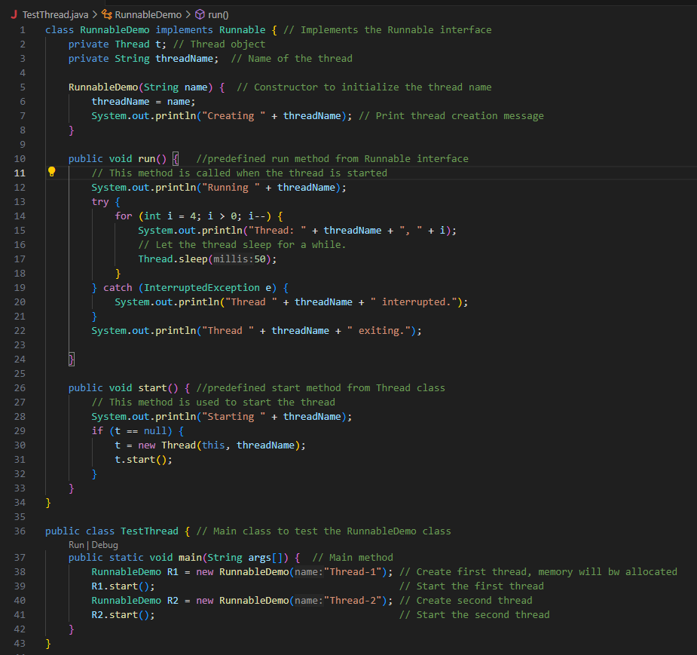
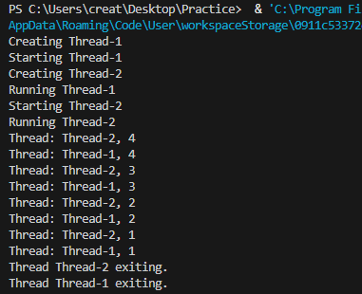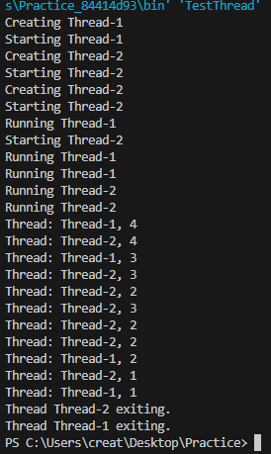

Task 3
In the above code … try extending Thread class… and observe the output..
Understand:
ex:
Public Class1 extends Thread{ }
Or
4public Class1 extends Class2 implements Runnable ( )

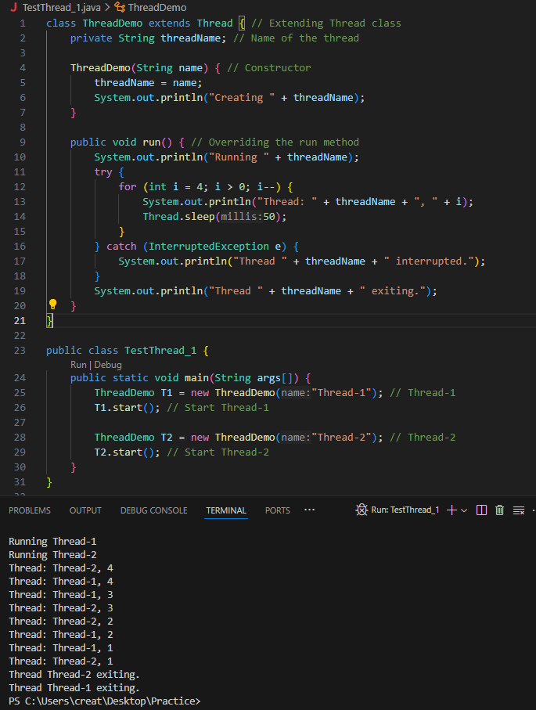
Use sync method
Task 4:

class Counter {
private int count = 0;

public void increment() {
count++;
}

public int getCount() {
return count;
}
}

class ThreadDemo extends Thread {
Counter counter;

ThreadDemo(Counter counter) {
this.counter = counter;
}

public void run() {
for (int i = 0; i < 10; i++) {
counter.increment();
}
}
}

public class Main {
public static void main(String[] args) {
Counter counter = new Counter();
ThreadDemo t1 = new ThreadDemo(counter);
ThreadDemo t2 = new ThreadDemo(counter);

t1.start();
t2.start();

try {
t1.join();
t2.join();
} catch (InterruptedException e) {
e.printStackTrace();
}

System.out.println("Final count: " + counter.getCount());
}
}
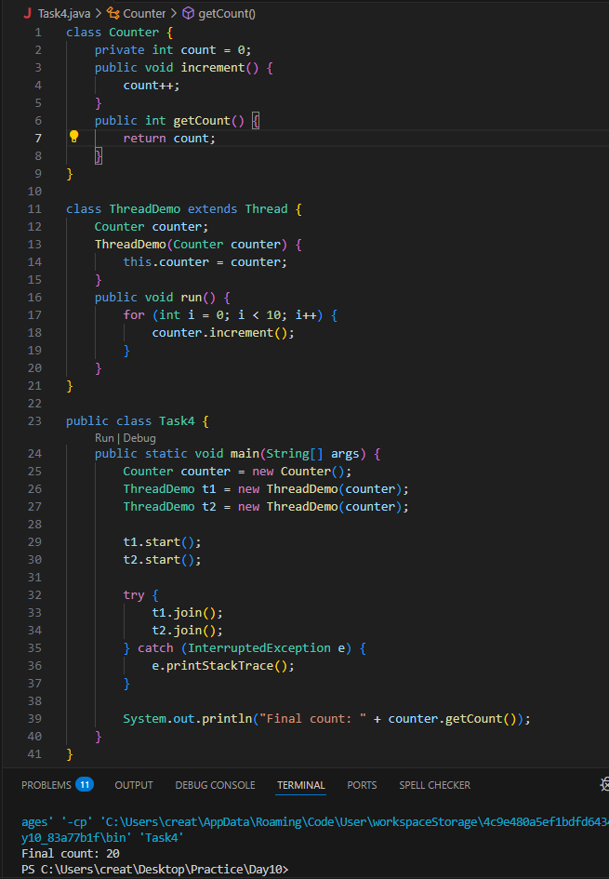

Task 5:

Use synchronized method:

11.54 to 11.59 5 min

Hint:
1. Synchronized Method:
Synchronize the entire method to ensure only one thread can execute it at a time.
class Counter {
private int count = 0;
public synchronized void increment() {
count++;
}
public int getCount() {
return count;
}
}

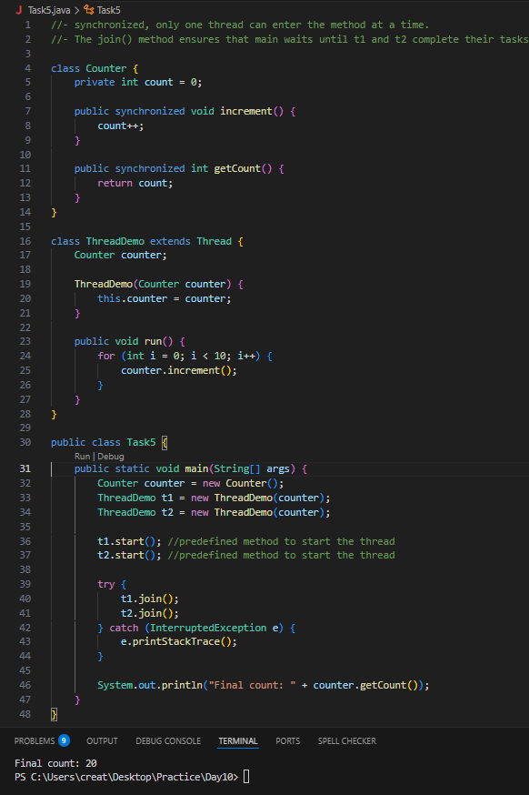

Task 6:
Using Sync Block
12.00 to 12.05
Hint:
2. Synchronized Block:
Synchronize a block of code instead of the entire method, providing more control and efficiency.
class Counter {
private int count = 0;
public void increment() {
synchronized (this) {
count++;
}
}
public int getCount() {
return count;
}
}

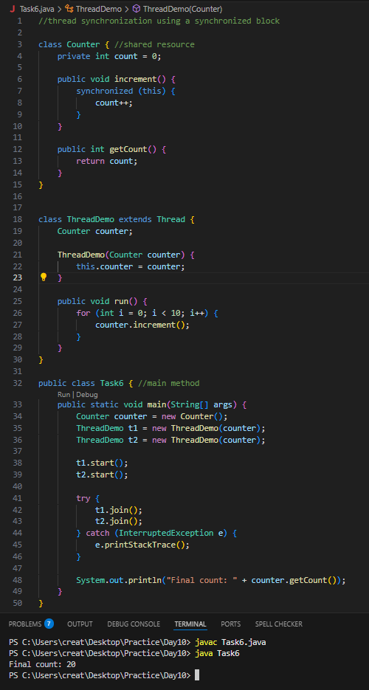
Task 7:
Using Static Sync
12.06 to 12.10
Hint:
3. Static Synchronization:
Synchronize static methods to ensure only one thread can execute them for the class, not the instance.
class Counter {
private static int count = 0;
public static synchronized void increment() {
count++;
}
public static int getCount() {
return count;
}
}
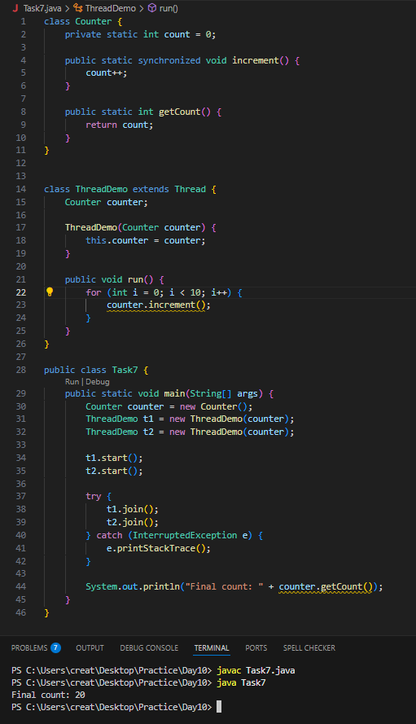

Task 8:
Using Locks
12.11 to 12.15
Hint:
4. Locks:
Use `java.util.concurrent.locks.Lock` for more sophisticated thread synchronization.
import java.util.concurrent.locks.Lock;
import java.util.concurrent.locks.ReentrantLock;
class Counter {
private int count = 0;
private final Lock lock = new ReentrantLock();
public void increment() {
lock.lock();
try {
count++;
} finally {
lock.unlock();
}
}
public int getCount() {
return count;
}
}
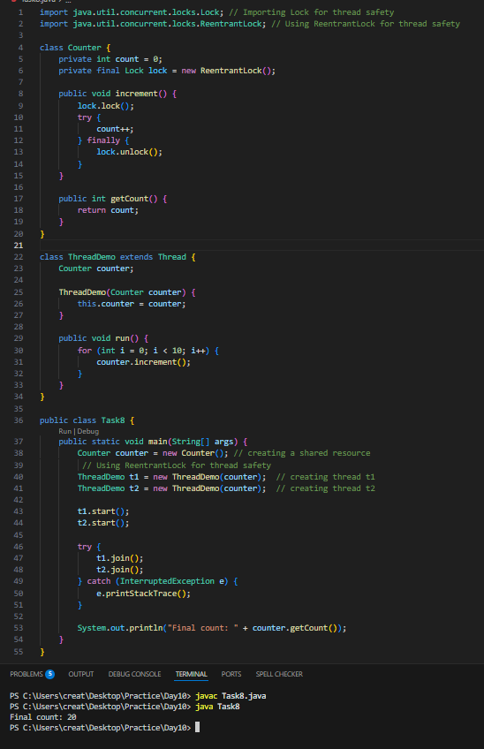

Task 9:

12.42 to 12.55 Sync Topic Rating will be done…
Task 10:

Dead Lock 👍

Example of Deadlock
class Resource {
synchronized void method1(Resource r) {
System.out.println(Thread.currentThread().getName() + " is executing method1");
try { Thread.sleep(100); } catch (InterruptedException e) {}
r.method2(this);
}
synchronized void method2(Resource r) {
System.out.println(Thread.currentThread().getName() + " is executing method2");
try { Thread.sleep(100); } catch (InterruptedException e) {}
r.method1(this);
}
}
public class DeadlockExample {
public static void main(String[] args) {
final Resource r1 = new Resource();
final Resource r2 = new Resource();
Thread t1 = new Thread(() -> r1.method1(r2), "Thread-1");
Thread t2 = new Thread(() -> r2.method1(r1), "Thread-2");
t1.start();
t2.start();
}
}

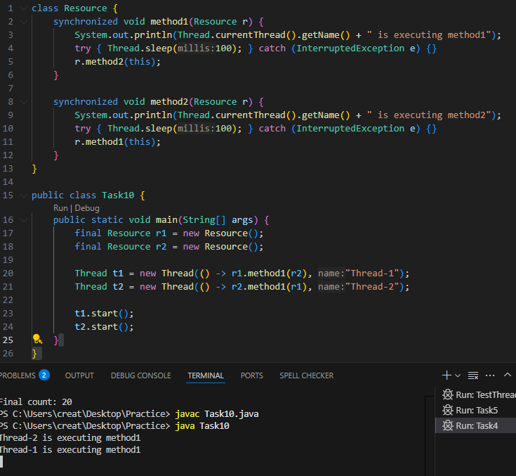

Task 11:
Inter- thread communication…
Example of Inter-thread Communication
class SharedResource {
private boolean ready = false;
synchronized void produce() {
try {
while (ready) {
wait();
}
System.out.println("Producing...");
ready = true;
notify();
} catch (InterruptedException e) {
e.printStackTrace();
}
}
synchronized void consume() {
try {
while (!ready) {
wait();
}
System.out.println("Consuming...");
ready = false;
notify();
} catch (InterruptedException e) {
e.printStackTrace();
}
}
}
public class InterThreadCommunicationExample {
public static void main(String[] args) {
SharedResource resource = new SharedResource();
Thread producer = new Thread(resource::produce);
Thread consumer = new Thread(resource::consume);
producer.start();
consumer.start();
}
}
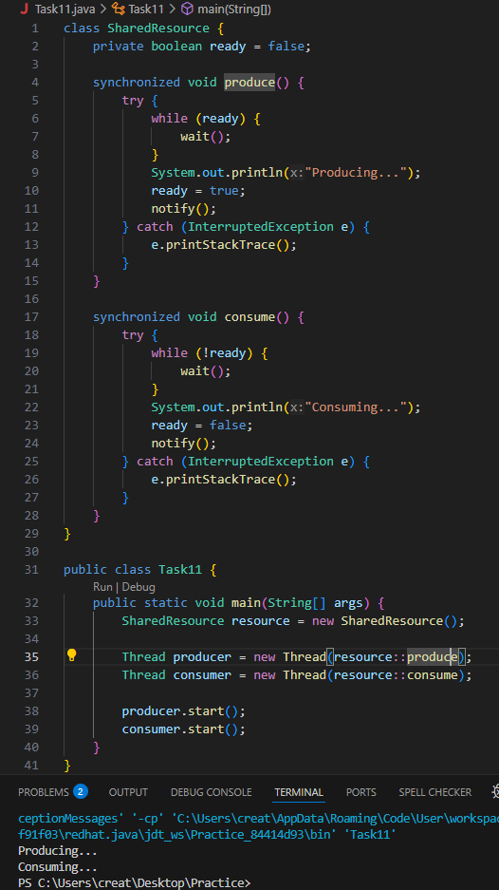
Task 12:
Interrupting a thread
Example of Interrupting a Thread
class InterruptibleThread extends Thread {
public void run() {
try {
while (!Thread.currentThread().isInterrupted()) {
System.out.println("Thread is running");
Thread.sleep(100);
}
} catch (InterruptedException e) {
System.out.println("Thread was interrupted");
}
}
}
public class InterruptExample {
public static void main(String[] args) {
InterruptibleThread thread = new InterruptibleThread();
thread.start();
try {
Thread.sleep(500);
thread.interrupt();
} catch (InterruptedException e) {
e.printStackTrace();
}
}
}
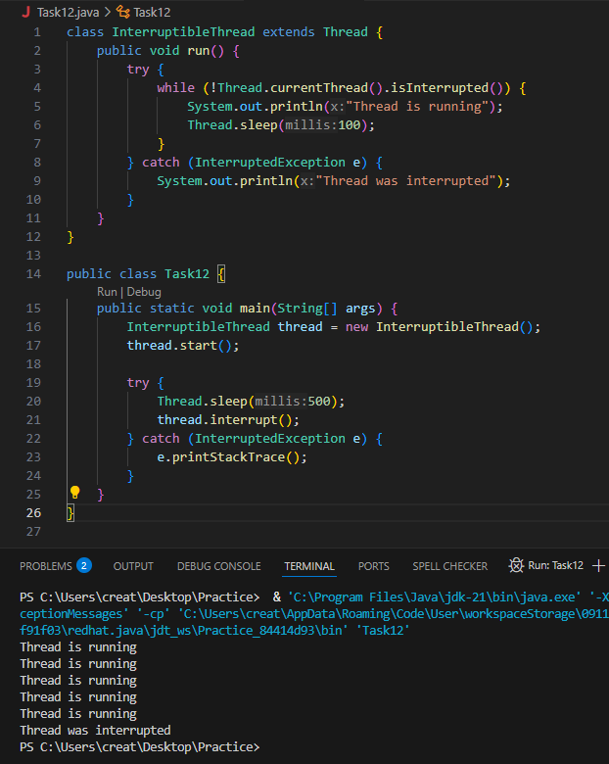

Task 13

Rating qn regarding Synchronisation…

Task 14::

What is a Thread pool?
A Thread Pool is like a group of workers (threads) that are always ready to do tasks.
Imagine we have a lot of small jobs (like printing files, handling web requests, or running background tasks). Instead of creating a new thread for every job (which takes time and memory), we can create a fixed number of threads in advance and reuse them for each task.
Example:
Think of a restaurant:
- We have 5 waiters (threads) always available.
- Whenever a customer (task) comes, a waiter is assigned to serve.
- Once done, the waiter becomes free again and is ready for the next customer.

======================================================================
File handling:
======================================================================

Task 15:

Run the below code and see the file with the given name created or not..
Run it again with I like India instead of I love India.. And see the file …
public class WriteByte
{
public static void main(String args[])
{
File f1=new File(“FileName01.txt”); \\ to create new file FileOutputStream outfile = null;
byte Text[] = {'I',’ ‘,’'L','O','V','E',’ ‘,'I','N','D','I’,’A'};
try
{
outfile = new FileOutputStream(f1);
outfile.write(Text);
}
catch(IOException e)
{
System.out.println(e);
System.exit(-1);
}
System.out.println("Write Byte");
System.out.println("Thank You...!!!");
}
}
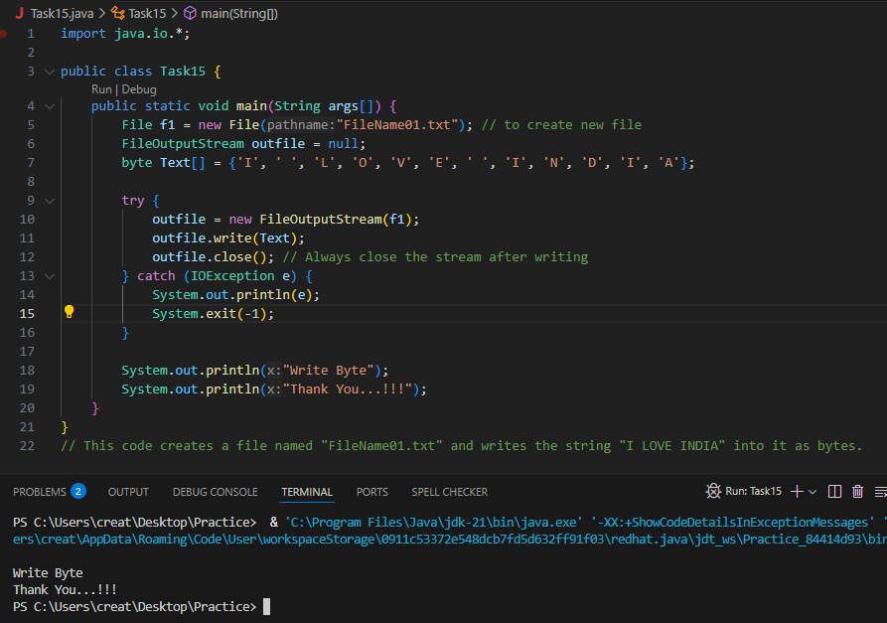

Task 16:

Try this code to see the output …
Write a program which reads byte from file.
import java.io.*;

public class Task16 {
public static void main(String args[]) {
try (FileInputStream infile = new FileInputStream("FileName01.txt")) {
int b;
while ((b = infile.read()) != -1) {
System.out.print((char) b); // Changed to print instead of println for better formatting
}
System.out.println(); // Ensure proper line break after output
} catch (IOException e) {
System.out.println("Error reading file: " + e.getMessage());
}
}
}
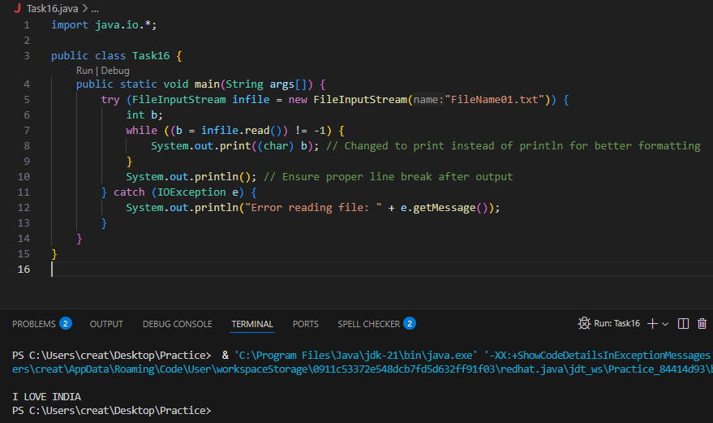

Task 17:
Taking input from the user and writing on the file…
Create a file and see the output…
import java.io.*;
import java.util.*;
public class WriteByte_1
{
public static void main(String args[]) {
FileOutputStream outfile = null;
//String s=args[0]; // to input string from command line Scanner sc=new Scanner(System.in);
String s=sc.nextLine();
byte b1[] = s.getBytes();
try
{
outfile = new FileOutputStream("FileName02.txt");
outfile.write(b1);
}
catch(IOException e)
{
System.out.println(e);
System.exit(-1);
}
System.out.println("Write Byte");
System.out.println("Thank You...!!!");
}
}
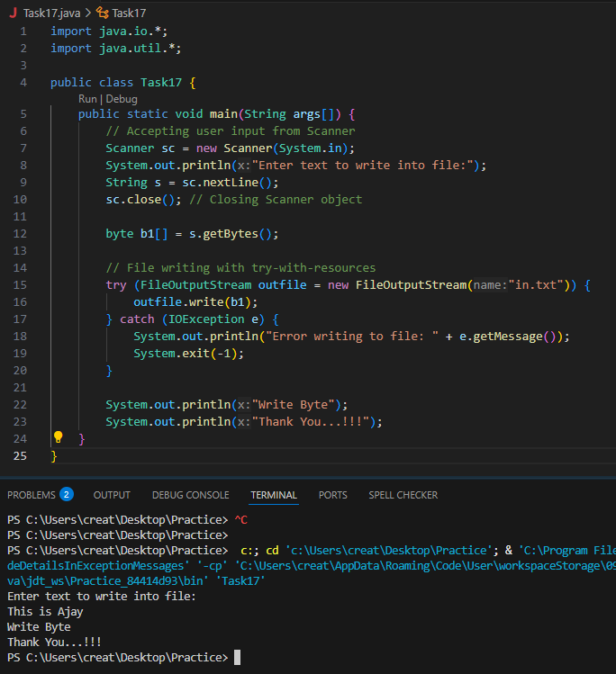

FileReader and FileWriter

Task 18:
Write a program which creates file and writes character into that file.
import java.io.*;
Class CharacterWrite {
public static void main(String args[]) {
File f1=new File("FileName03.txt");
FileWriterfw = null;
try {
fw=new FileWriter(f1);
fw.write("ahmedabad \n");
fw.write(" baroda \n");
fw.close();
}
catch(FileNotFoundException e)
{ System.out.println("Sorry..!! File Not Found...!!!");
}
catch(IOException e)
{
System.out.println(e.getMessage());
}
System.out.println(“ write operation done!!”);
}
}

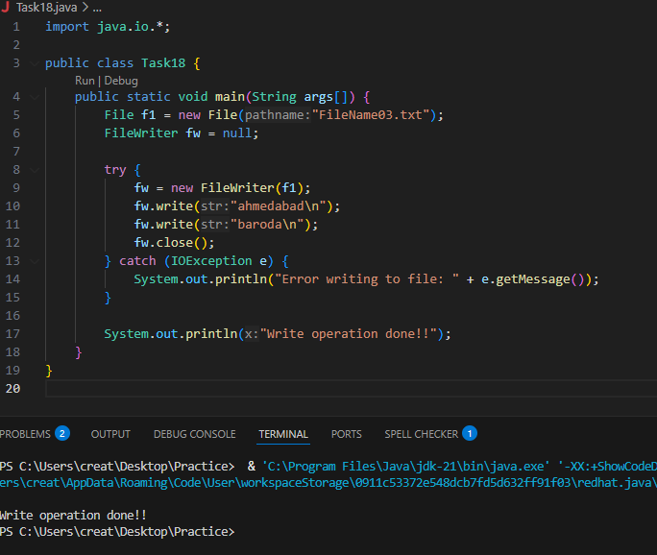

Task 19
Write a program which reads character from file.
import java.io.*;

class Readchar {
public static void main(String args[]) {
FileReader fr = null;
try {
fr = new FileReader("FileName03.txt");
int ch;
while ((ch = fr.read()) != -1) {
System.out.print((char) ch);
}
System.out.println("Reading complete");
fr.close();
} catch (FileNotFoundException e) {
System.out.println("Sorry..!! File Not Found...!!!");
} catch (IOException e) {
System.out.println(e.getMessage());
}
}
}

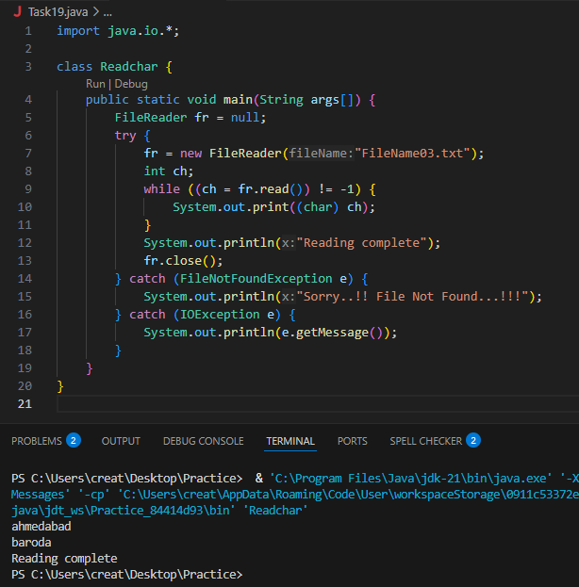
Task 20

Write a program to read one byte at a time from a file and copy it into another file immediately.
import java.io.*;
classCopyByte
{
public static void main(String args[])
{
try
{
byte b=0;
FileInputStream infile = new FileInputStream("NewFile01.txt");
FileOutputStreamoutfile = new FileOutputStream("NewFile05.txt");
while(byteread != -1)
{
b = (byte)infile.read();
outfile.write(b);
}
System.out.println("Byte Copied From in.txt to out.txt FIle ");
}
catch(FileNotFoundException e)
{
System.out.println("Sorry..!! File Not Found...!!!");
}
catch(IOException e)
{
System.out.println(e.getMessage());
}
}
}

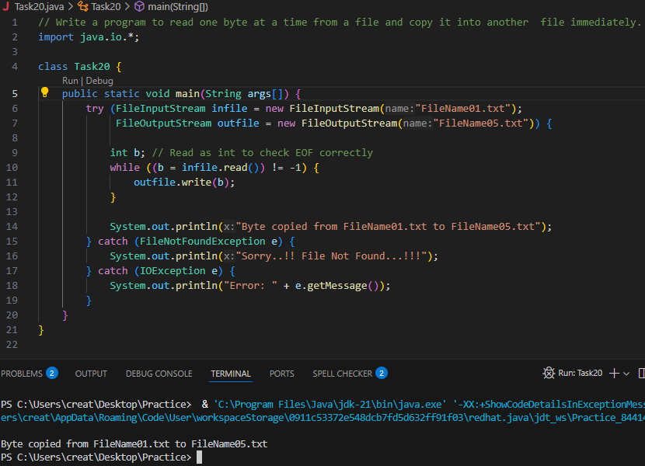
Task 21:

Merging two files to 3rd file..

Write a program to merge two files in third file.
import java.io.*;
classFileMergeDemo
{
public static void main(String args[])
{
try
{
FileInputStream file1 = new FileInputStream("File1.txt"); FileInputStream file2 = new FileInputStream("File2.txt"); SequenceInputStream file3 = new SequenceInputStream(file1, file2); BufferedInputStream br1 = new BufferedInputStream(file3); BufferedOutputStream br2 = new BufferedOutputStream(System.out); intch;
while((ch = br1.read())!=-1)
{
br2.write((char)ch);
}
br1.close();
br2.close();
file1.close();
file2.close();
System.out.println("Merge Two File Sucessfully ");
}
catch(IOException e)
{
System.out.println("Sorry..!! File Not Found...!!!");
}
}
}

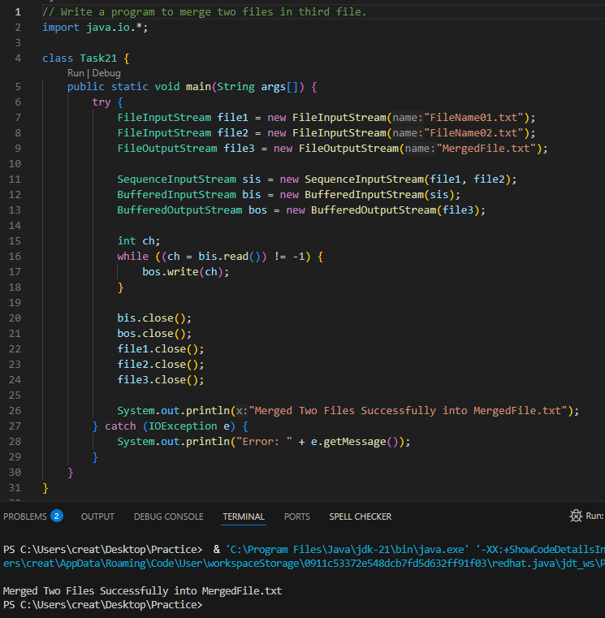

Task 22:

Write an application to rename a file. Use the renameTo() method of File to accomplish
/*this task. The first command line argument is the old filename and the second is the newfilename.
*/
import java.io.*;
classFileRenameDemo
{
public static void main(String args[])
{
File f1 = new File(args[0]);
File f2 = new File(args[1]);
f1.renameTo(f2);
System.out.println("Rename File " +f1+" To "+f2+" Sucessfully "); }
}
Output :
javacFileRenameDemo.java
javaFileRenameDemo input1.txt abc.txt

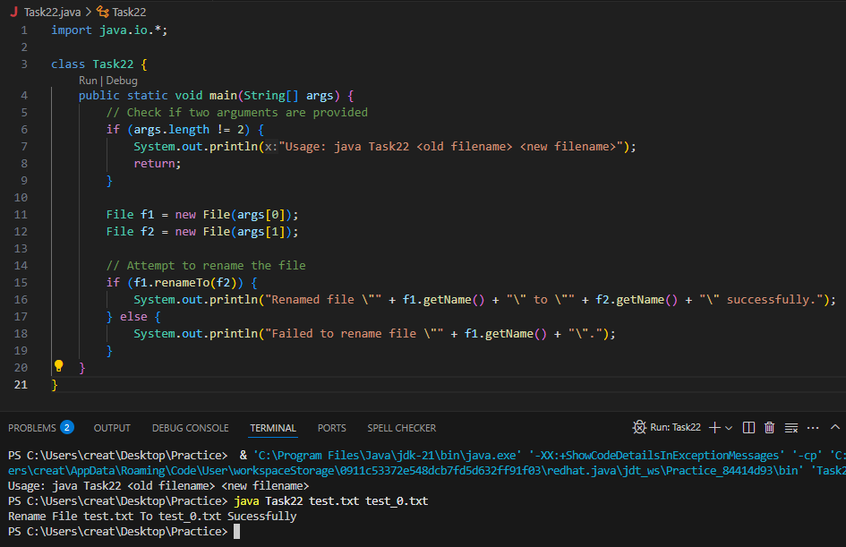

Task 23 👍
===============================================
Task 23 and 25 - Buffered reader and writer — for large files to be read.
===============================================

import java.io.BufferedReader;
import java.io.FileReader;
import java.io.IOException;

public class ReadFileExample {
public static void main(String[] args) {
try (BufferedReader br = new BufferedReader(new FileReader("largefile.txt"))) {
String line;
while ((line = br.readLine()) != null) {
System.out.println(line);
}
} catch (IOException e) {
e.printStackTrace();
}
}
}
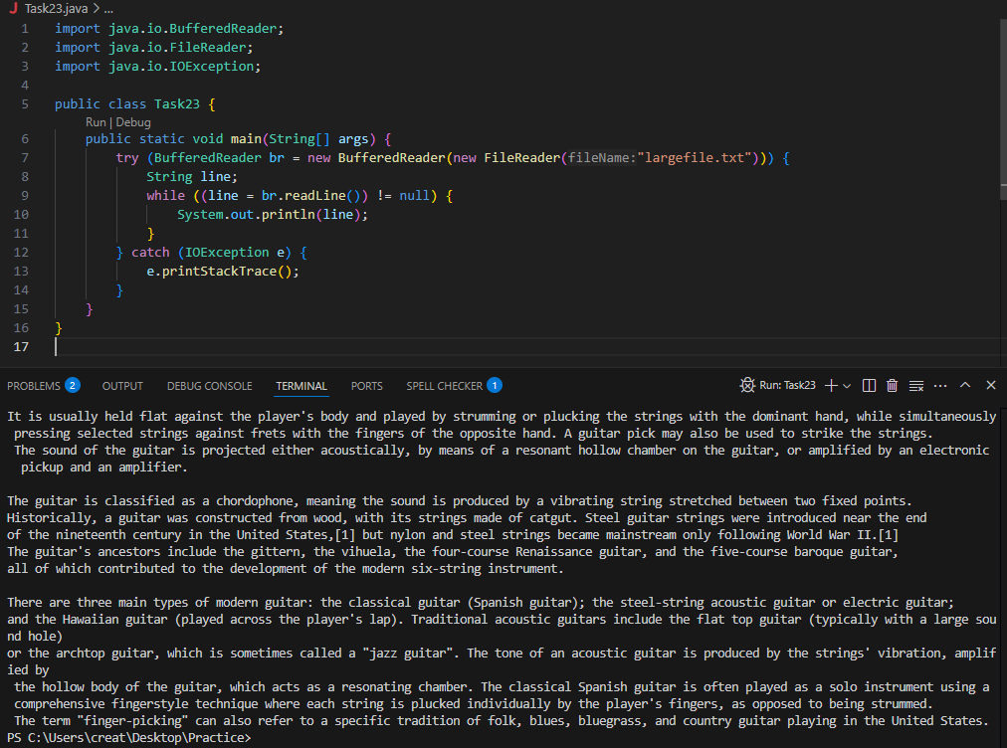

Task 24 non buffered

import java.io.FileReader;
import java.io.IOException;

public class NonBufferedReaderExample {
public static void main(String[] args) {
try (FileReader fr = new FileReader("largefile.txt")) {
int ch;
while ((ch = fr.read()) != -1) {
System.out.print((char) ch);
}
} catch (IOException e) {
e.printStackTrace();
}
}
}

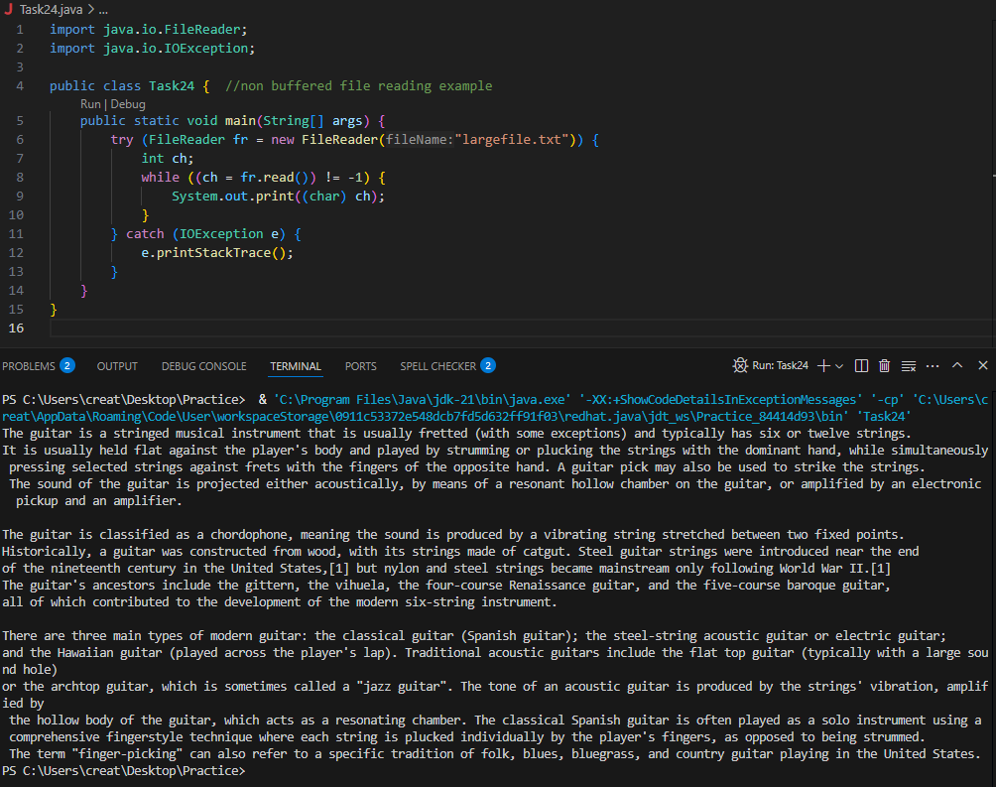

Task 25:

Buffered Writer

import java.io. BufferedWriter;
import java.io.FileWriter;
import java.io.IOException;

public class BufferedWriterDemo {
public static void main(String[] args) {
String filePath = "example.txt";
String content = "Hello, World!\nThis is a BufferedWriter example.";

// Initialize BufferedWriter with a FileWriter
try (BufferedWriter writer = new BufferedWriter(new FileWriter(filePath))) {
// Write content to the file
writer.write(content);
System.out.println("Content written to file.");
} catch (IOException e) {
System.err.println("An error occurred: " + e.getMessage());
}
}
}
